EDA Chief Executive held talks in Portugal

Lisbon - 16 July, 2019

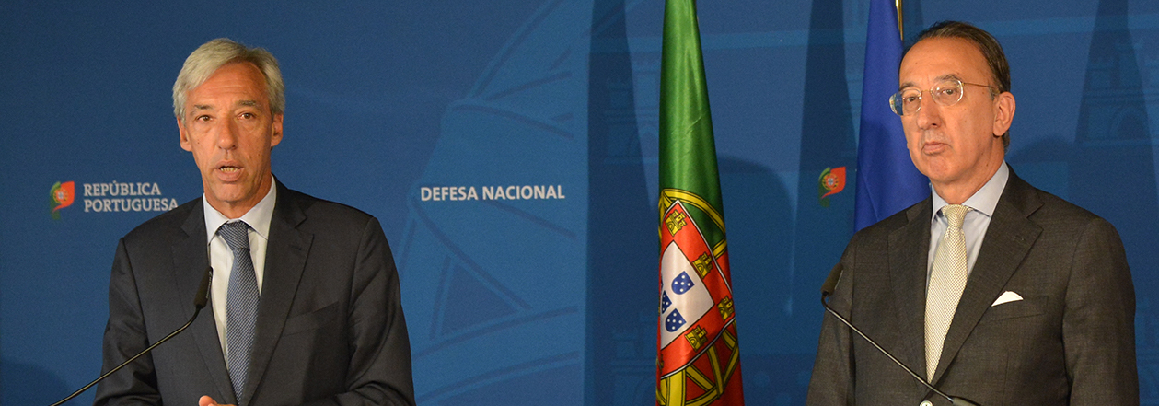

**EDA Chief Executive Jorge Domecq was in Lisbon today for talks with the Portuguese Minister of National Defence, João Cravinho, as well as with the Director-General for National Defence Policy, Nunho Pinheiro Torres, the Director-General for Defence Resources, Alberto Coelho, the Political Director-General at the Ministry of Foreign Affairs, Pedro Costa Pereira, the Director for Defence and Security, Jorge Aranda, as well as the Deputy Political Director-General for Defence and Security, Ana Paula Moreira. He also met with representatives of the Portuguese Defence Industry.**  
  
The main topics discussed during the meetings included the practical implementation of the revised EU Capability Development Priorities adopted in June 2018 (especially through the Strategic Context Cases developed by EDA) as well as the state of play and way ahead in the implementation of the EU defence initiatives (PESCO, CARD, European Defence Fund). In this respect, particular emphasis was put on the need to ensure coherence among all those initiatives and a steady focus on the agreed CDP priorities. Portugal’s current and potential future contributions to EDA projects and programmes, the implications of the Agency’s recent Long-Term Review, EU-NATO relations, Military Mobility and the defence and security related priorities of the upcoming Portuguese Presidency of the Council of the EU (first half of 2021) were also discussed. 

Multinational Helicopter Training Centre

Mr Domecq thanked the Portuguese authorities for their willingness to host the future Multinational Helicopter Training Centre (MHTC) which should open its doors in 2021 at Sintra Airbase. The Centre will secure a long-term home for EDA’s three helicopter projects: HTC, HTIC and HEP, which have been successfully sponsored by the Agency since 2009.  The MHTC concept was agreed by the EDA Steering Board on 18 February 2019 and covered objectives, missions and expected structure of the centre. Subject to a further Steering Board decision, the MHTC Project Team could begin its work in autumn to produce the Technical Agreement (TA) that will form the legal basis for the Centre’s operations.  *“We very much appreciate Portugal’s very strong support to EDA’s helicopter activities and look forward to a close working relationship with the host nation”*, Mr Domecq commented.

Minister Cravinho stated: *"It will be a great satisfaction to host the Multinational Helicopter Training Centre, in Sintra. The Ministry of Defence and the Portuguese Air Force developed a strong business case in order to show that Portugal could host this training centre of great importance for several European countries, and we are very pleased that this has been recognized"*.

*"Portugal is very pleased to work closely with the EDA. EDA plays a unique and necessary role in the development of Europe’s Defence Identity, which we believe to be of great significance in this very rapidly changing world. European defence cooperation has expanded in an unprecedented manner in the past couple of years, and Portugal is keen to participate in this process"*, Mr Cravinho added.